HARDWARE SETUP
To install the hardware and make it ready for firmware upload, following steps are required:
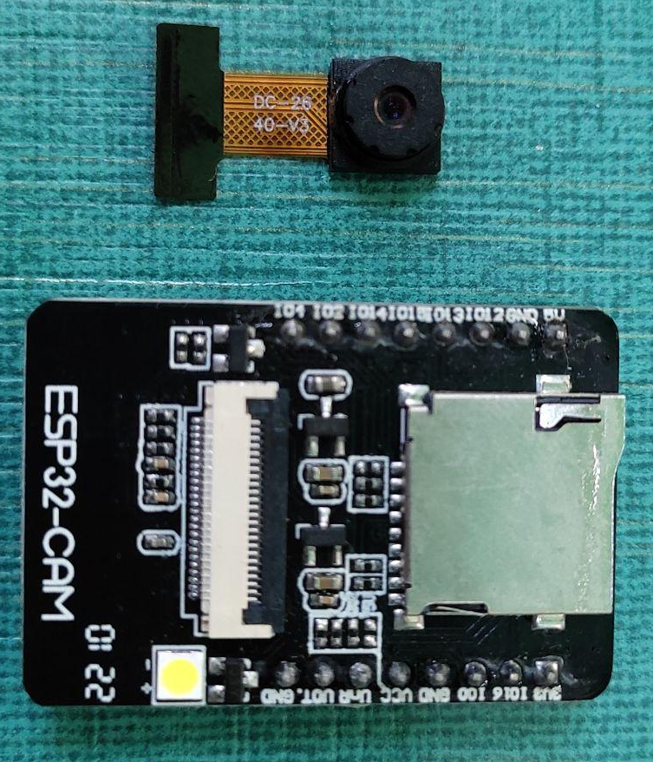
- Firstly, connect the Camera Sensor with the FPC connector of ESP32-CAM , as shown:
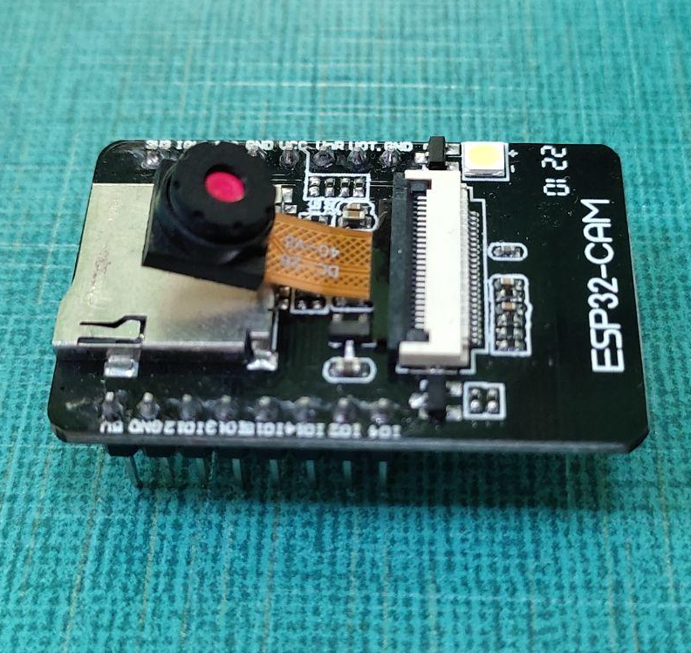
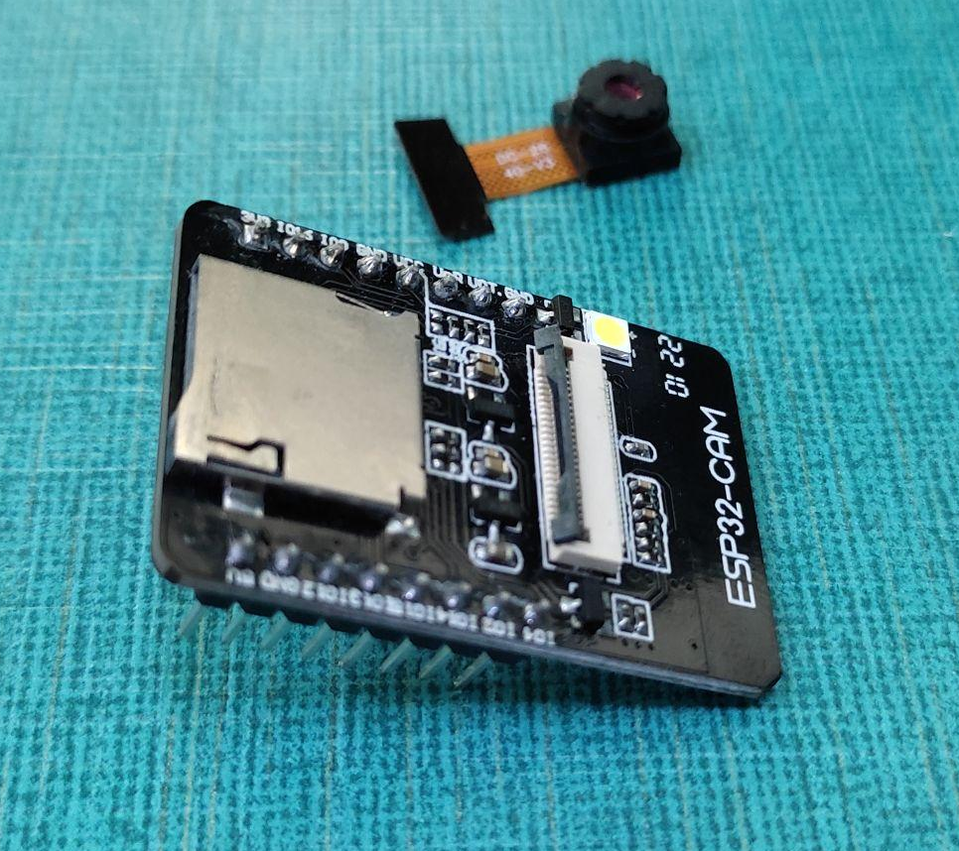
- Connect ESP32 - CAM with USB-to-TTL converter by using female-to-female jumper wires, as shown:
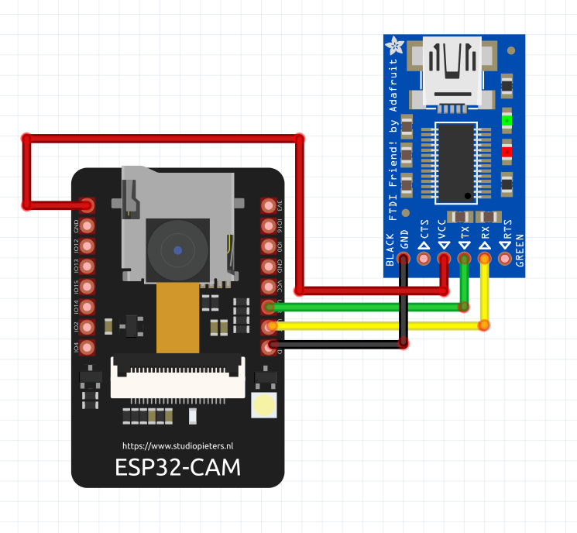
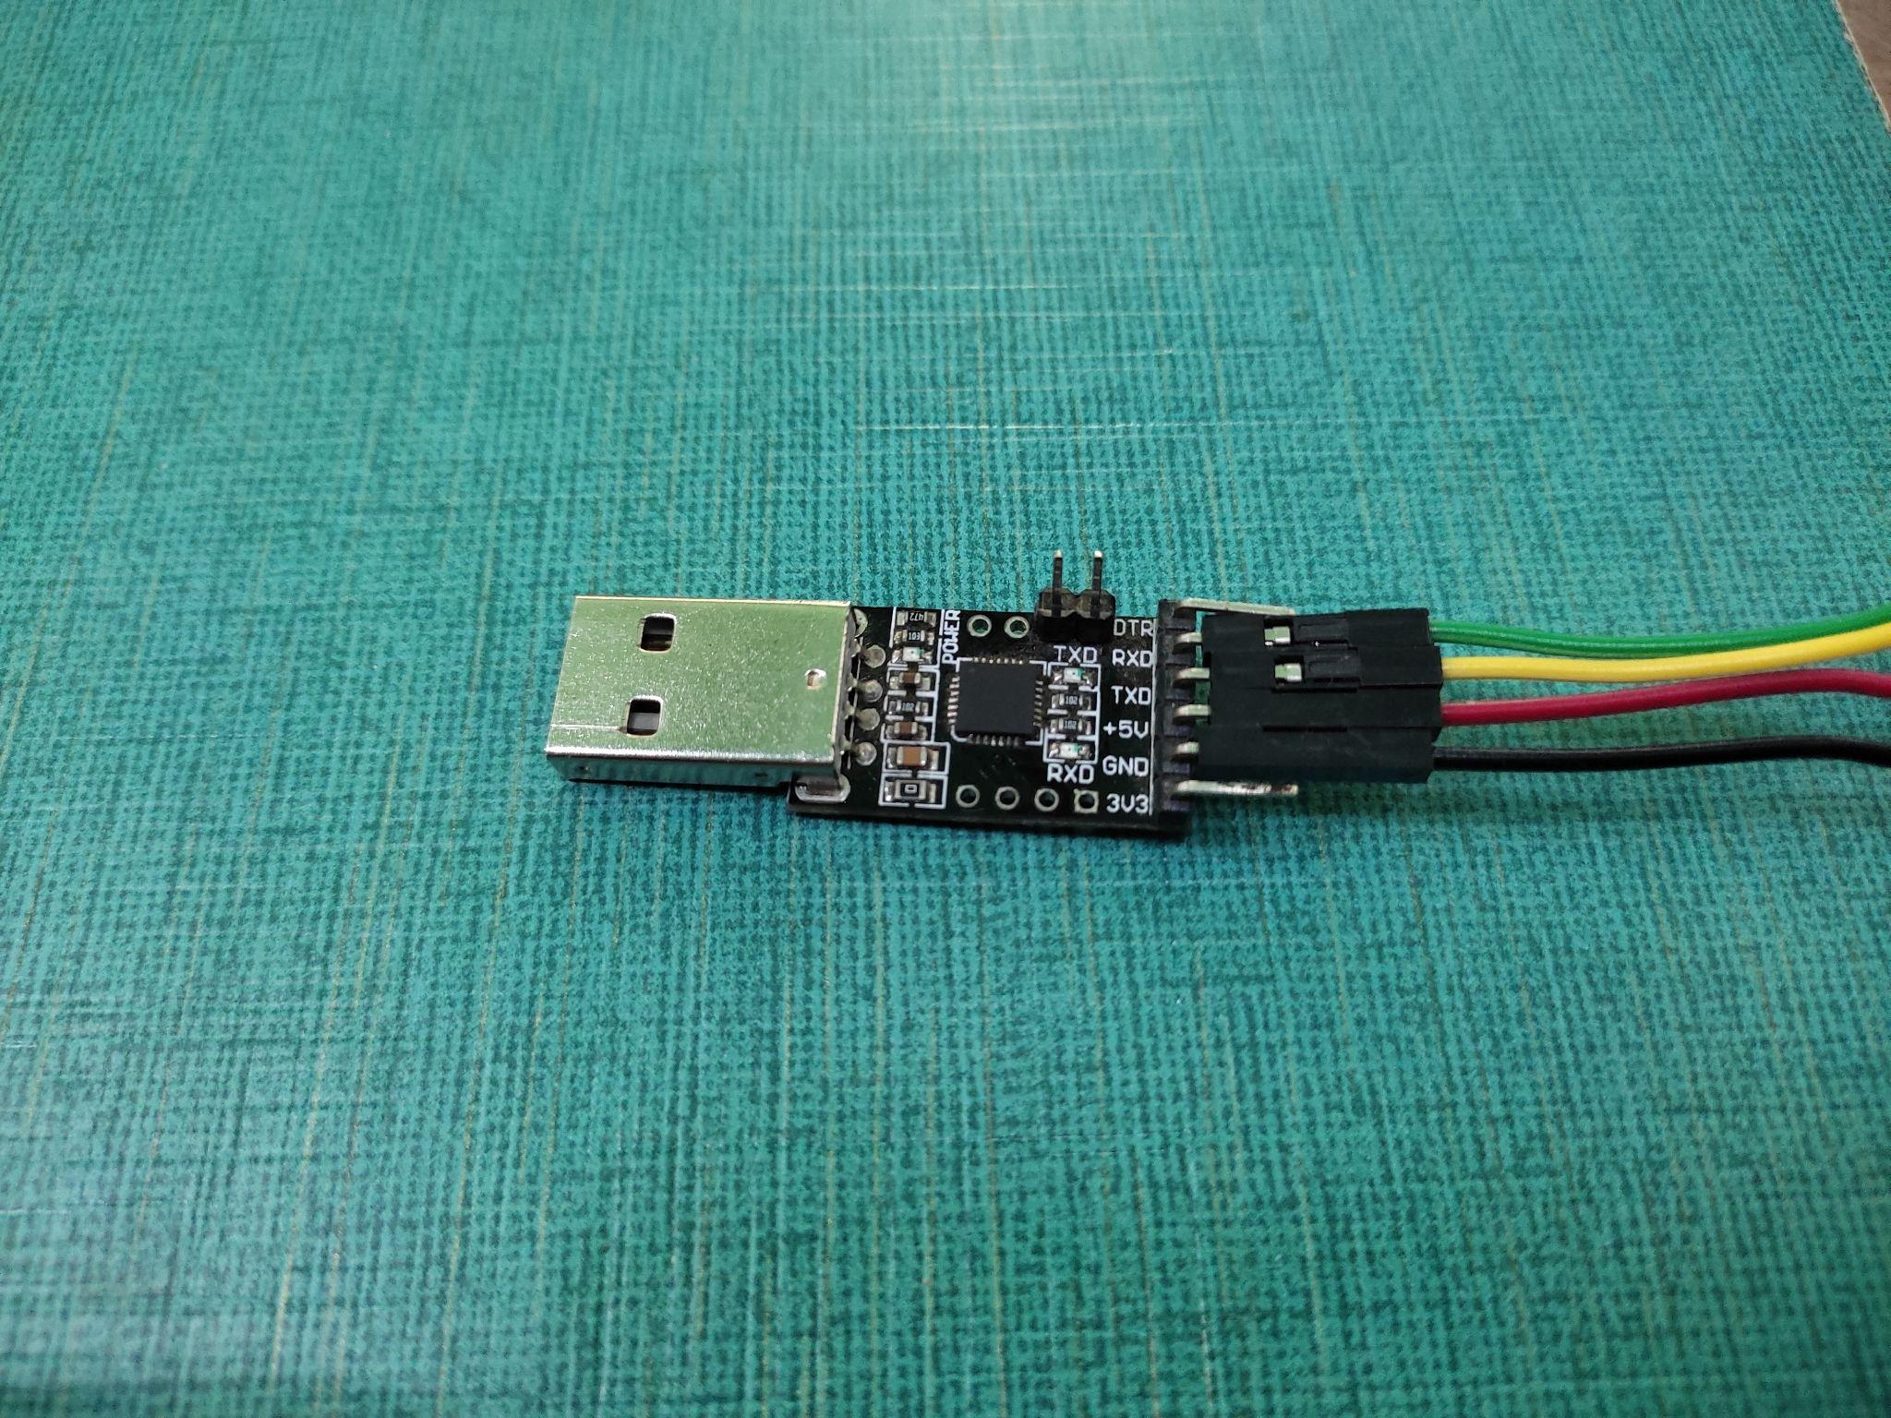
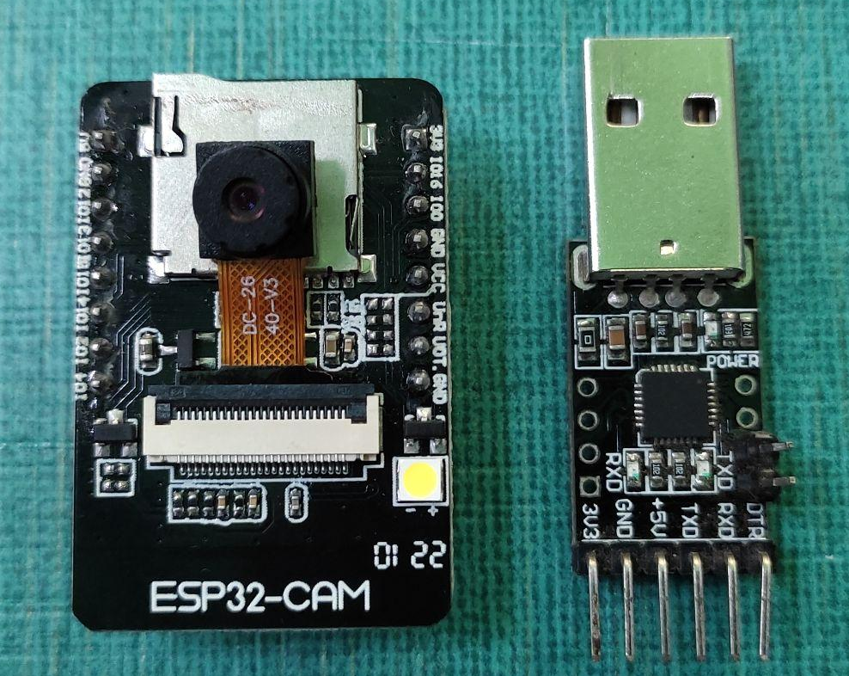

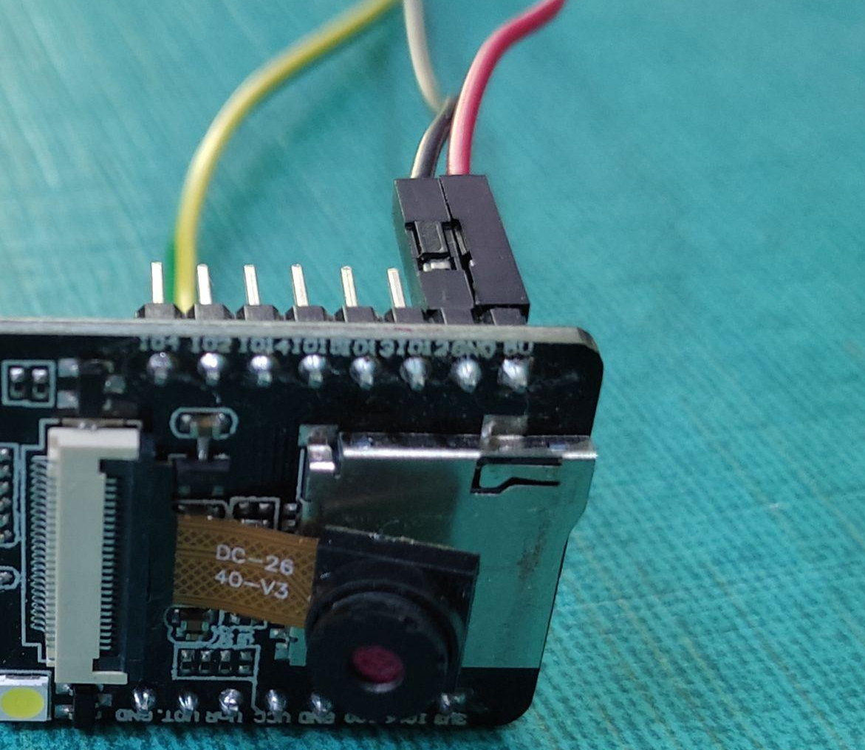
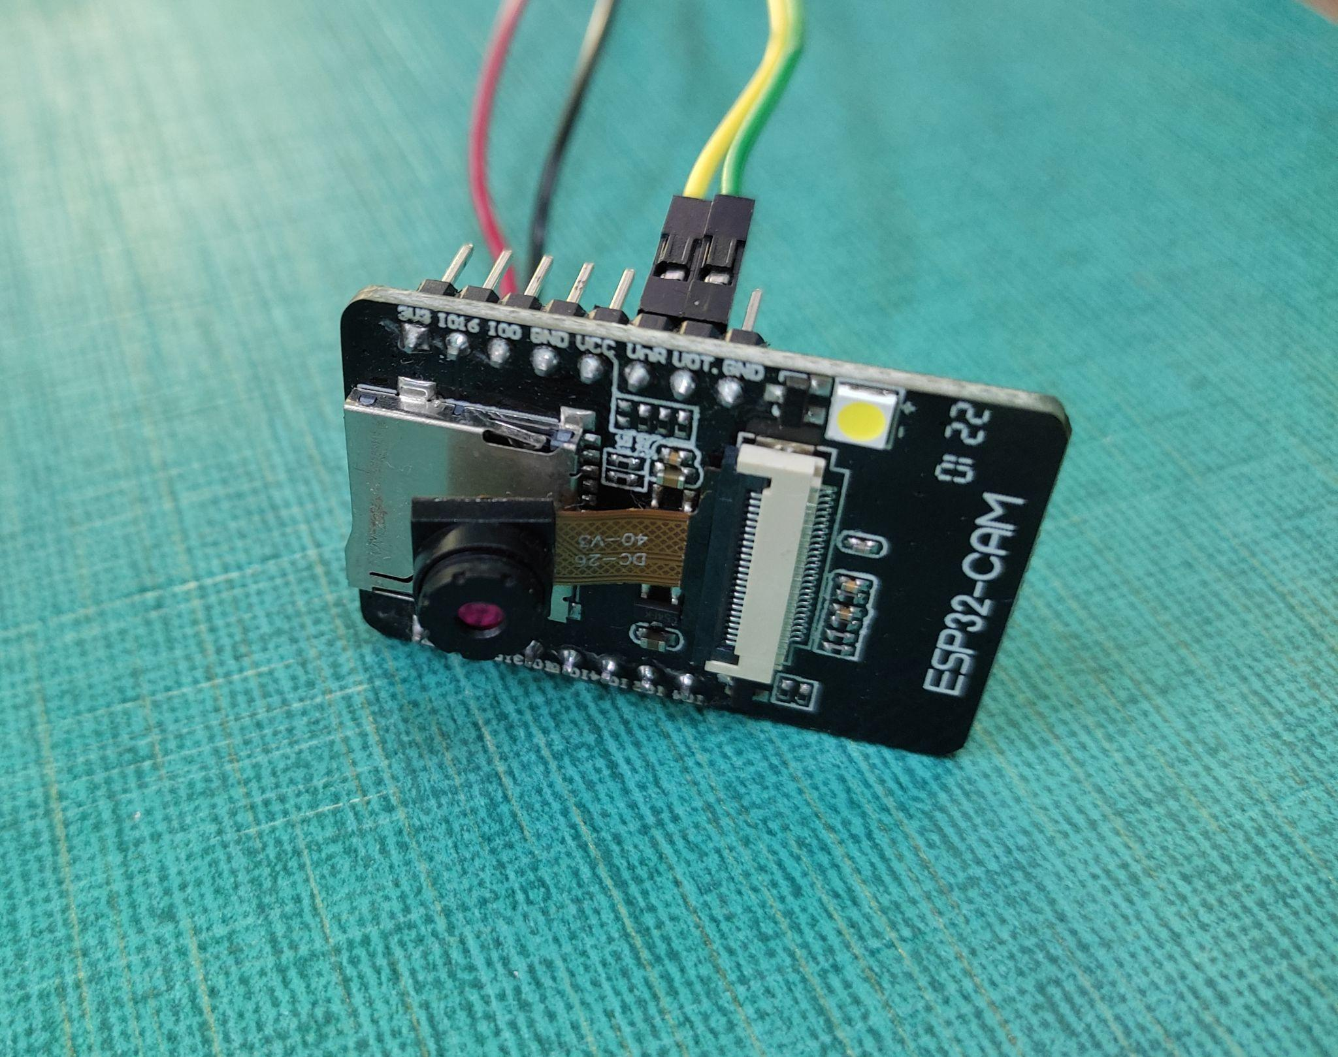

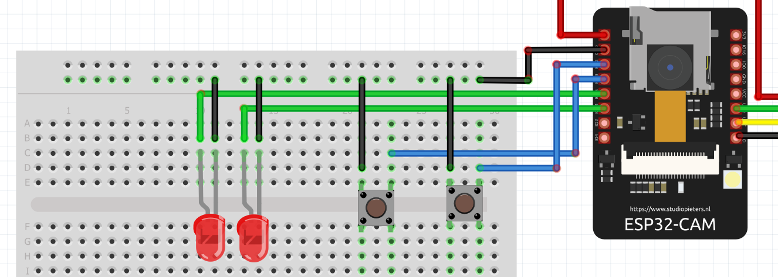
- Connect Leds and Push Buttons with the above circuit, by using breadboard and jumper-wires.
- Finally, connect the USB-to-TTL converter with your PC.

SOFTWARE SETUP

- Install ESP-IDF in Windows
- Installing VS Code
- Integrating ESP-IDF with VS Code
- Setting Up Firebase

ESP-IDF Installation in Windows:
Opens the official ESP32 ‘getting started’ webpage by Espressif. Scroll down until you reach the Manual Installation section. Here click ‘Windows Installer.’
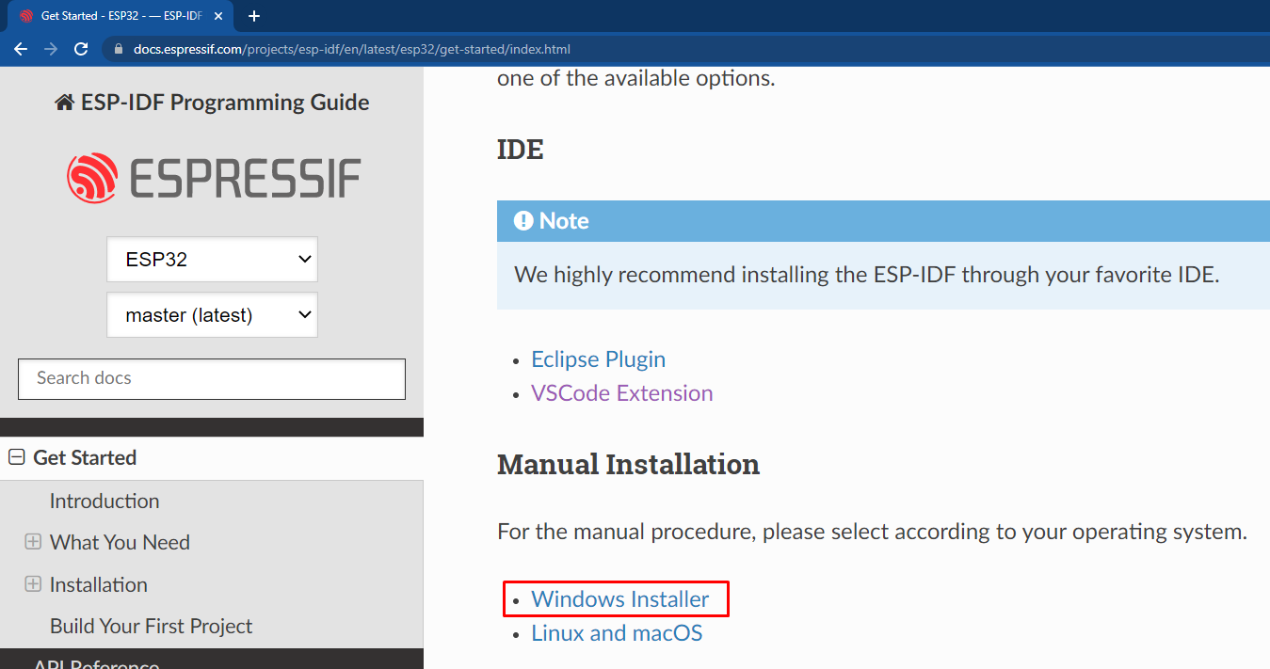
You’ll redirect to a new page and now click on “Windows Installer Download”. After that select the “Universal Online Installer”.
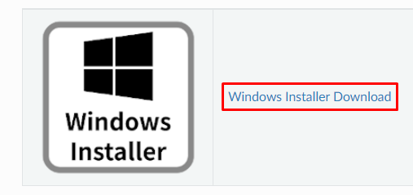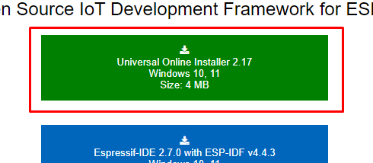

Now, open the downloaded .exe file, and begin esp-idf installation.
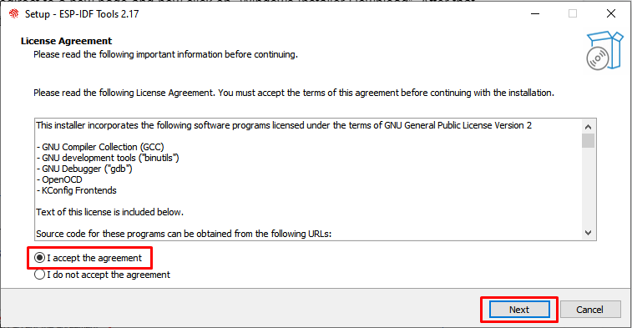
Click ‘Next’ on Pre-Installation Check. After that select “Download ESP-IDF”.
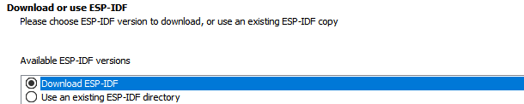

Select the “V4.4.3(release version)”.
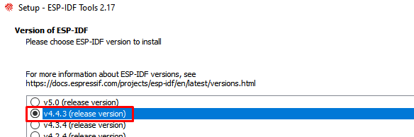
In the “Select Components” tab, remain it as it is and click “Next”. Now the installation begins. Click the Finish button to exit the setup.

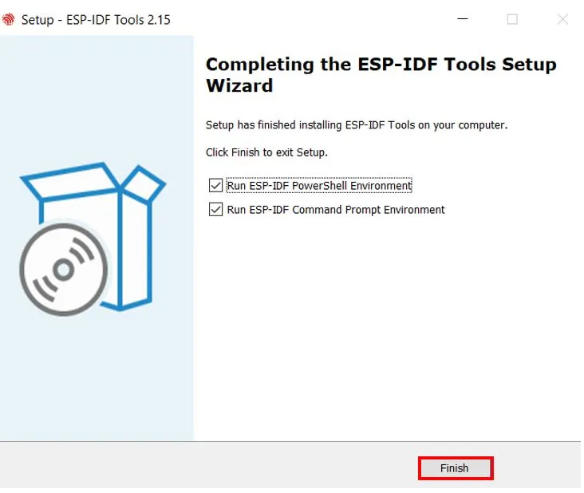

Installing VS Code:
To download and install the visual code editor IDE, visit the official website of vs-code.
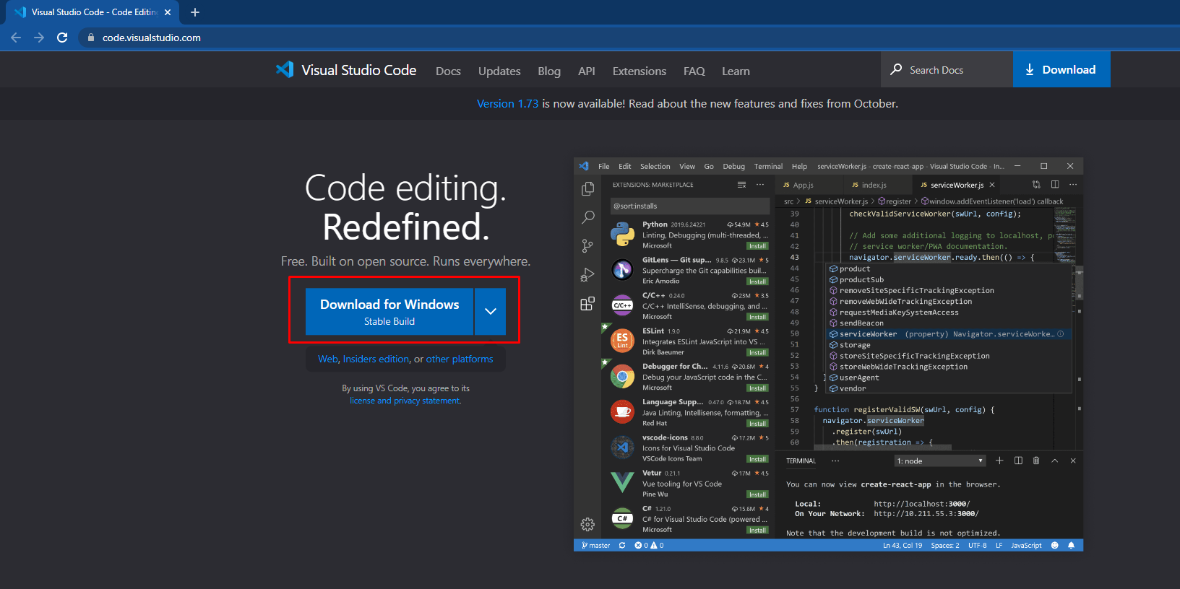
After the download is complete, click it. The following License Agreement window opens up. Here you will accept the agreement and then press ‘Next.’
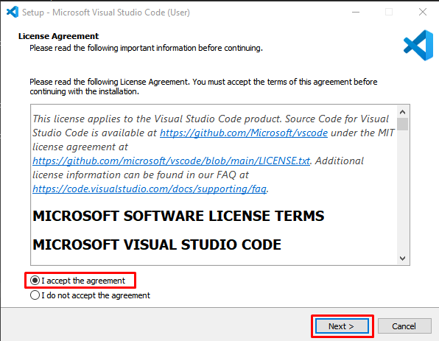
Additionally, you can also select additional tasks according to your needs. After that click ‘Next’.
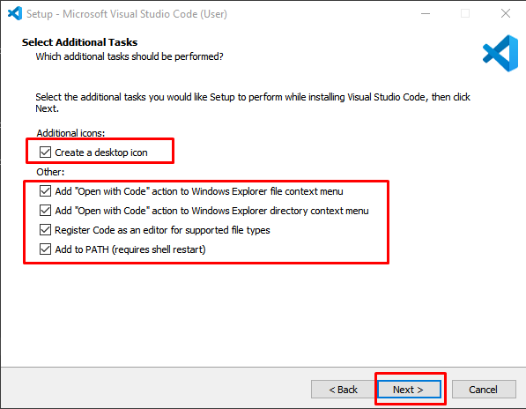

Now the setup is ready to install. The red block highlights the options we ticked on our way. Finally, click the “Install” button.
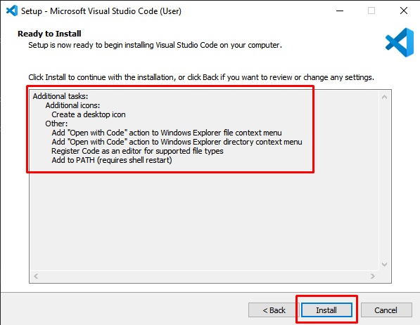

VSCode installation is done.

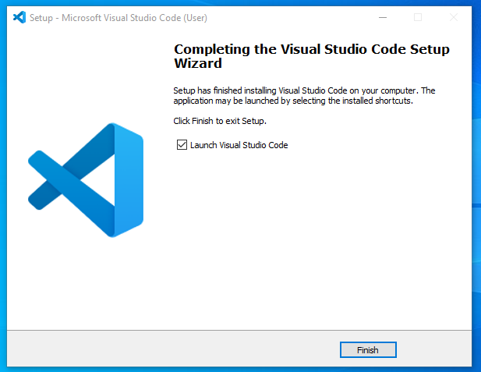

Integrating ESP-IDF with VS Code:
Open Vs-code extensions by pressing Ctrl + Shift + X or click its icon. Type ‘espressif idf’ in the search bar and install it.

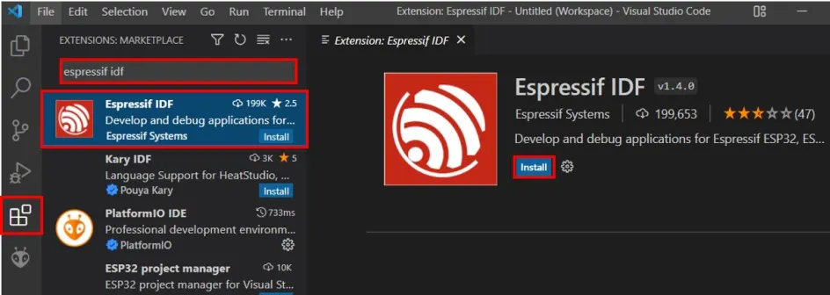

Go to View->Command Palette,
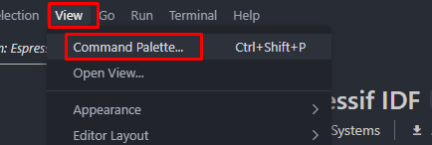

Type “Configure ESP-IDF extension” and Select the option.
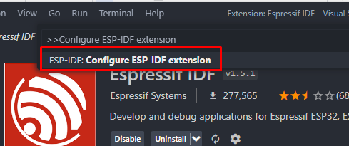

Select the “Use Existing Setup”
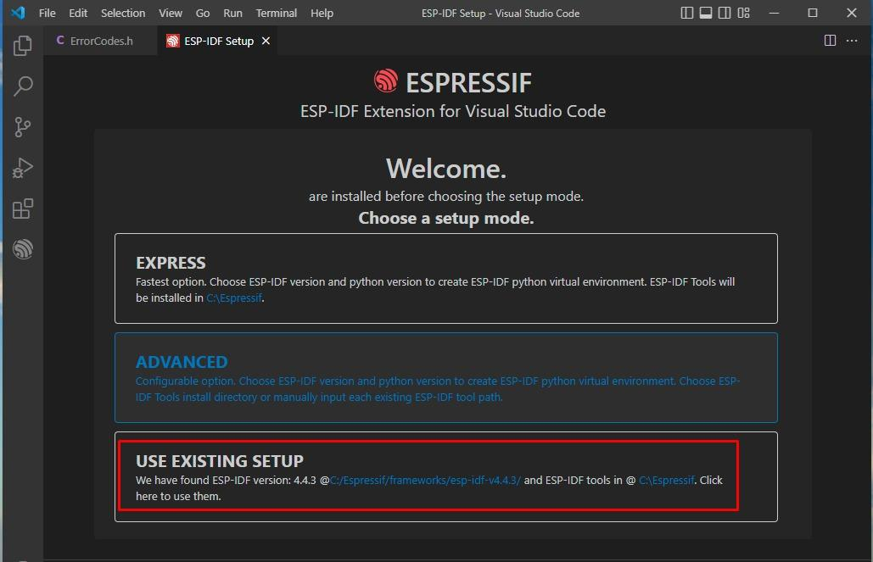

VS-code fetched the already installed ESP-IDF.
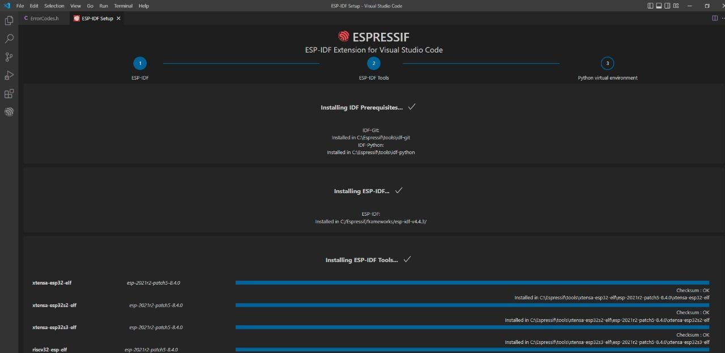

VS-code is configured successfully.
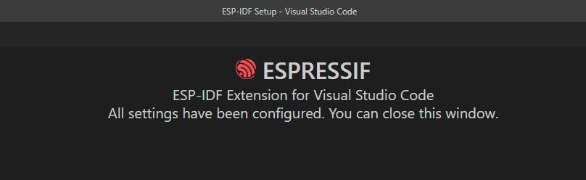

FireBase Setup:
Now, setup the firebase by following these steps;
Open the official Firebase website and click on “Get Started”.
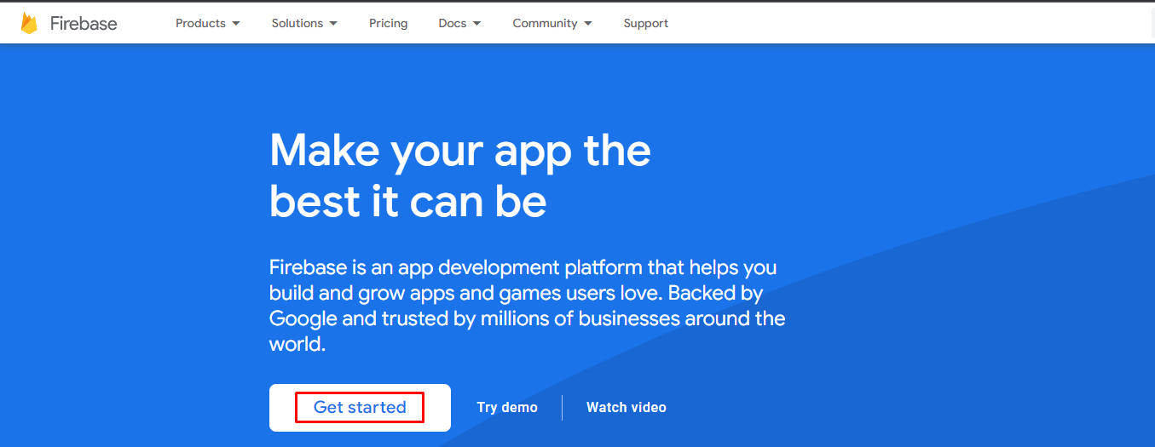

Sign-in with the provided credentials, and the “Firebase Projects” page will open. Now click on “MatKenn-ERPSystem”.
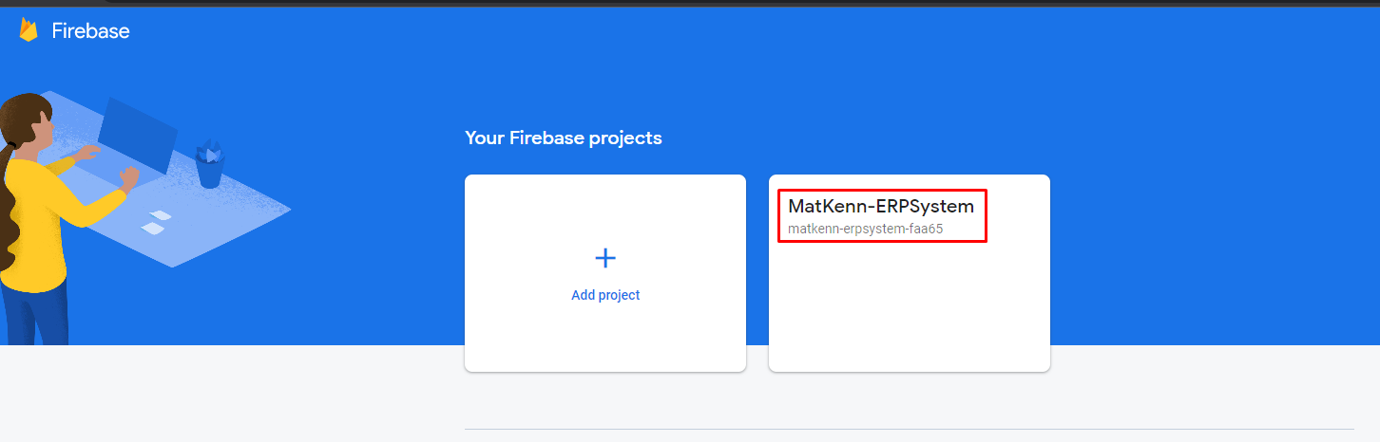

Go to Realtime Database->Data, and here you can access the qr-scanner data.
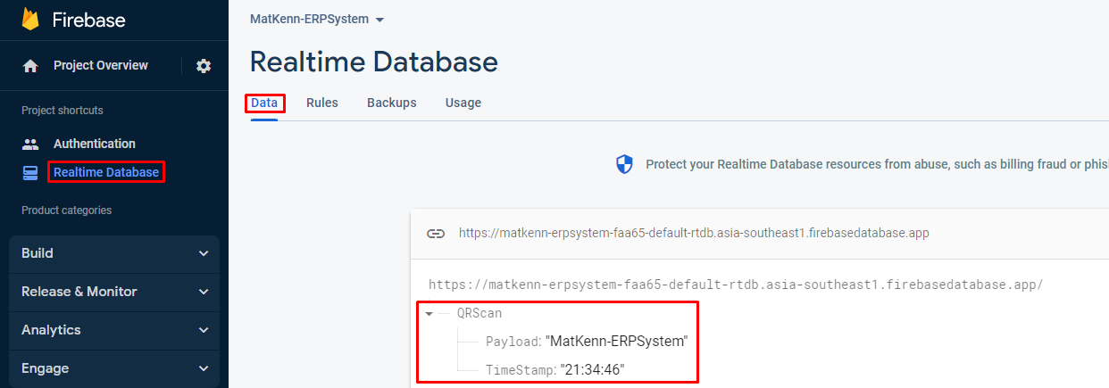

BUILDING, FLASHING & MONITORING (FIRMWARE):

- Project Build:
Go to your project directory and open the project in VS code.

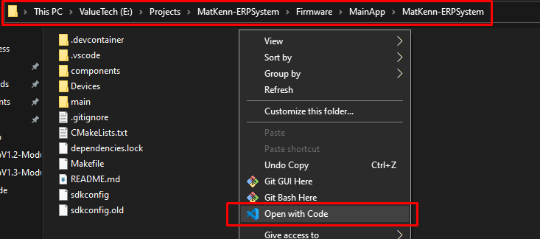

Go to “Device Manager” and check your ESP32-Cam COM Port. (make sure your board is connected).

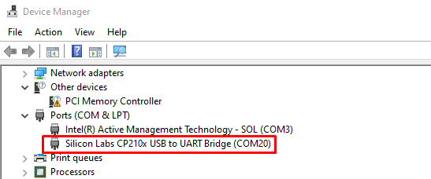

Now, Select this COM Port on Vs Code.

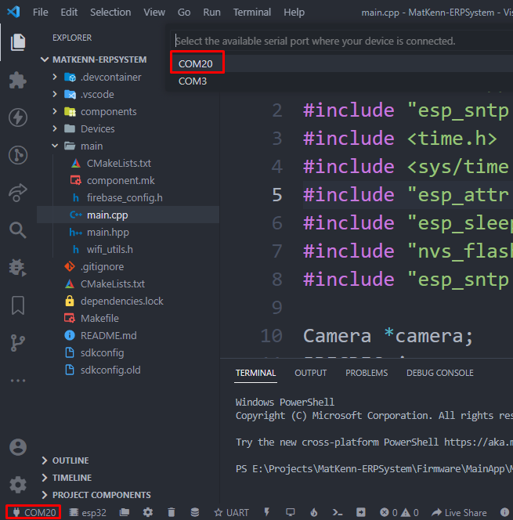

Select “Custom target” as your device target and press ESC.
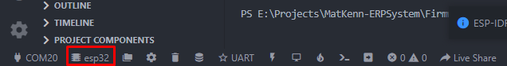
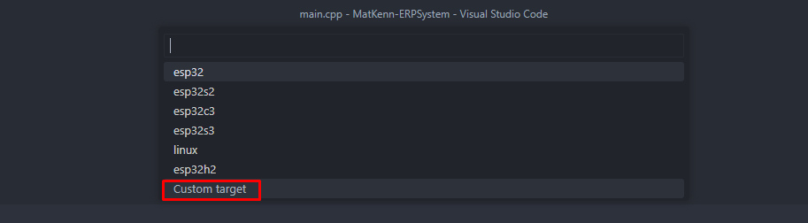

Select “UART” in flash method.
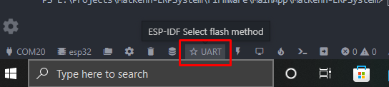
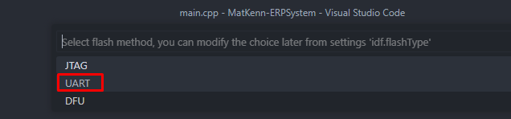
Select the “menuconfig” and change the following parameters & click save.
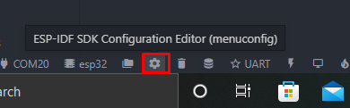
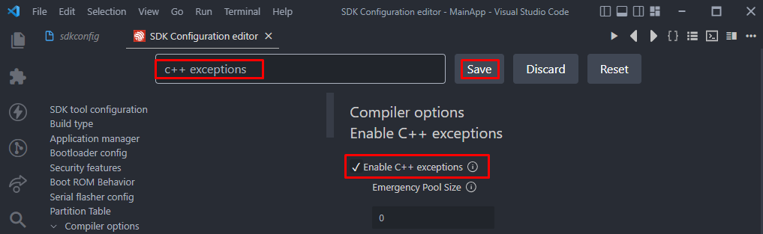
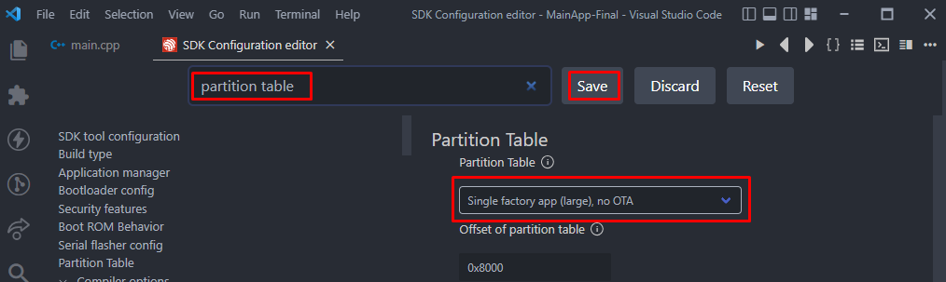

Now open the esp-idf terminal, and Build the Project.
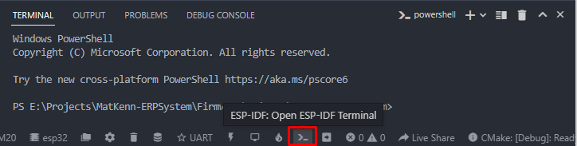
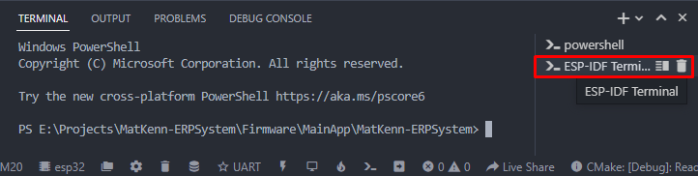

Run the following command in ESP-IDF terminal, “ idf.py build ”

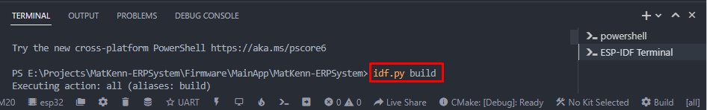
The project build is complete and ready to flash.
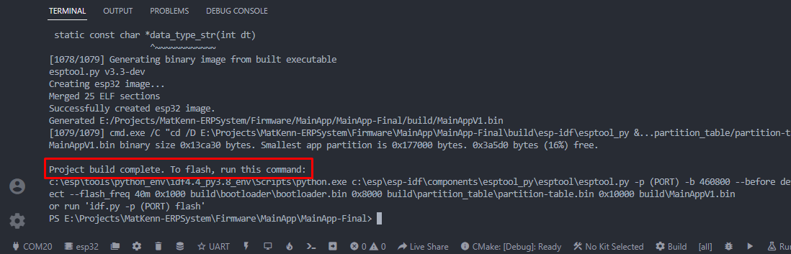

- Flashing:
First you have to connect the GPIO0 to GND and press the reset button of the ESP32-Cam board.
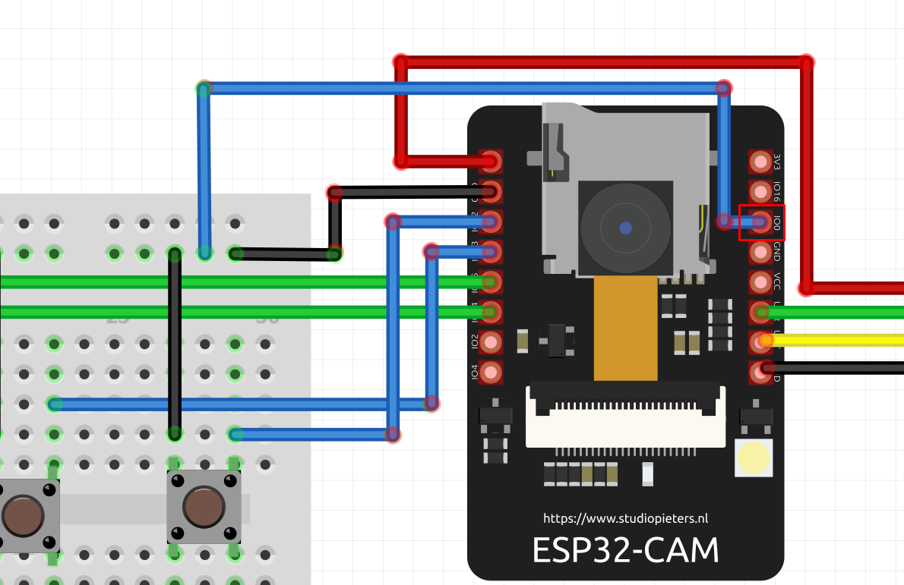

Now, run this command on the esp-idf terminal, “ idf.py -p COM20 flash monitor”
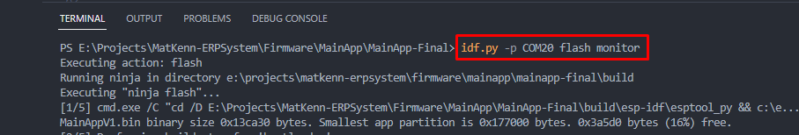
Flashing is done. Remove “GPIO0” from “GND” and press the reset Button of the board.
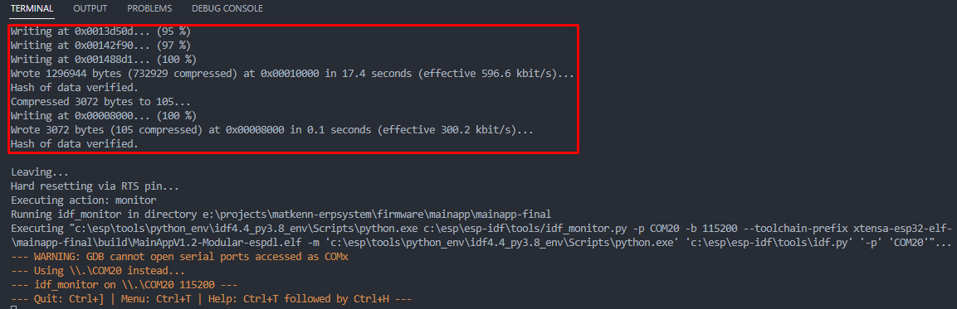

You can monitor the logs on the terminal also;
